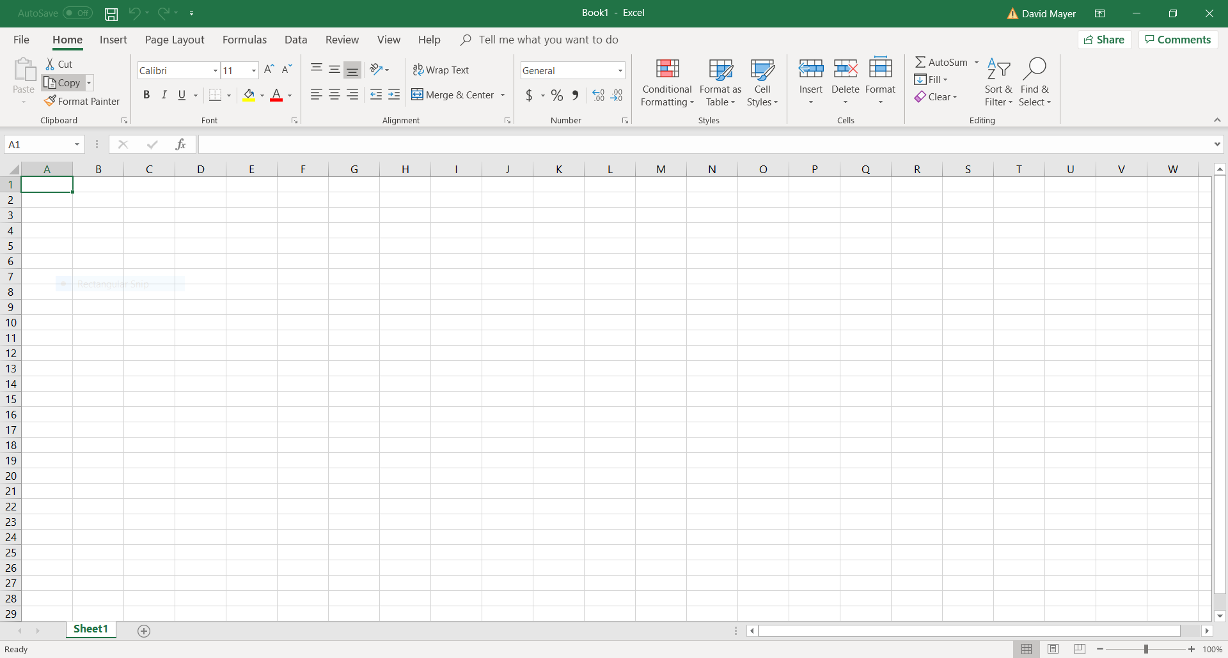

3

2

1

**#1:** This is the “Home” tab for Microsoft Excel. When you open a new “Blank Workbook”, this is what you see. The workbooks in Excel are similar to documents in Word. In this tutorial, you will learn how to modify these workbooks. I will assume you have already finished the Microsoft Word tutorial, but you should understand everything in this tutorial even if you don’t have any experience in Word.

**#2:** This red circle shows you where you can change the “Zoom” of your workbook. “Zoom” works like a magnifying glass, so you can make everything in the workbook larger from your perspective. This tutorial does not cover printing, so be aware that sizing issues require different steps to solve during printing.

**#3:** Here are some menus that might look familiar. In the “Font” menu, you can change the looks of your text. Right now, you can see the default font of “Calibri” with size “11”. The **B** under Calibri stands for **bold** text, the *I* stands for *Italic* text, and the U stands for underlined text.

* All three of these items **(#1**, **#2**, and **#3**) are basically the same in Microsoft Word and Microsoft Excel.

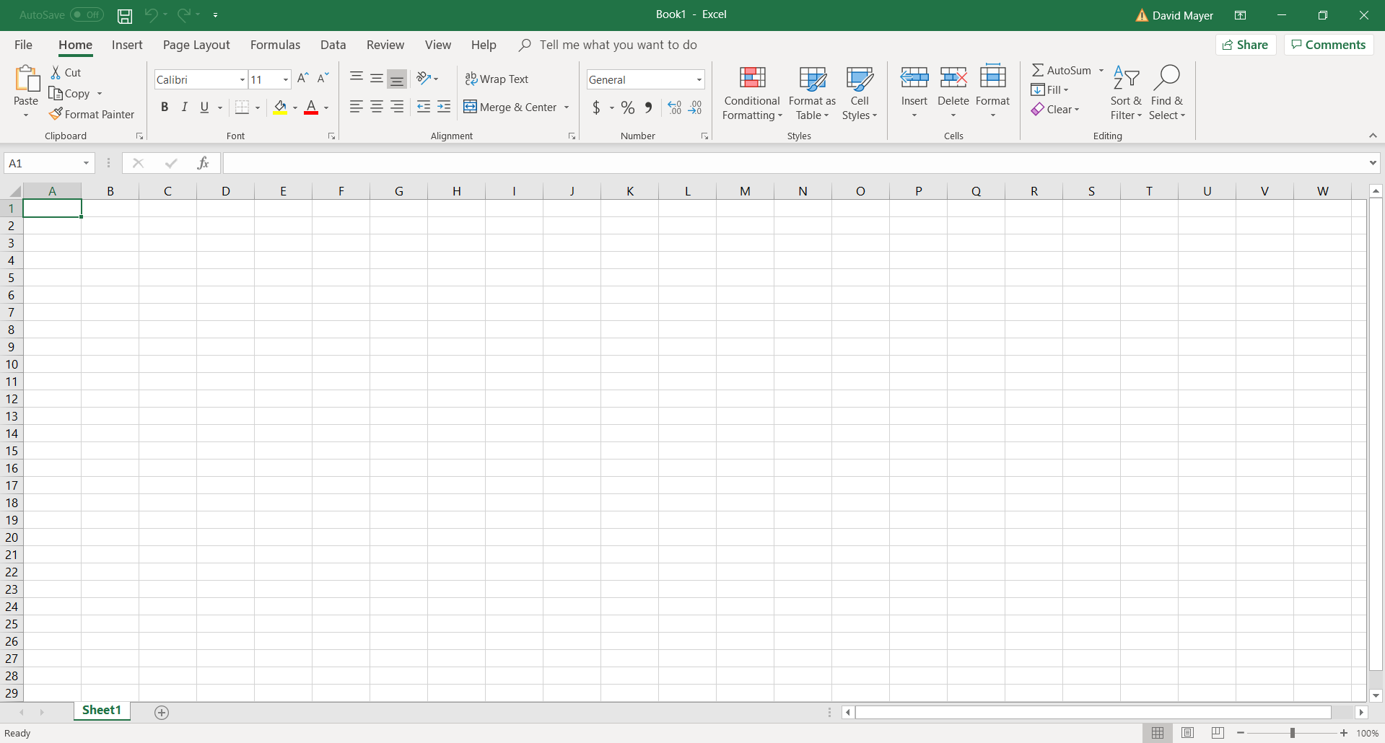

3

2

1

**#1:** When you open up a new workbook, it names the workbook “Book1” by default, but you will need to give the workbook a name when you save. “Sheet1” is the default name for the first page of the workbook. Click the plus button next to Sheet 1 to get a new sheet (page).

**#2:** I’ll go over this in depth later. For now, just remember that you will need to switch from the “Home” tab to the “File” tab to save your workbook or to open up an old workbook.

**#3:** The “Insert”, “Formulas”. And “Data” tabs are used fairly often, but we will stick to the “Home” tab for this tutorial. Microsoft Excel has a “Help” tab in which you can contact support and type in any questions. We also have some helpful Excel tutorial videos that we linked on our Circles website. I recommend <https://www.youtube.com/watch?v=rwbho0CgEAE> by Technology for Teachers and Students.

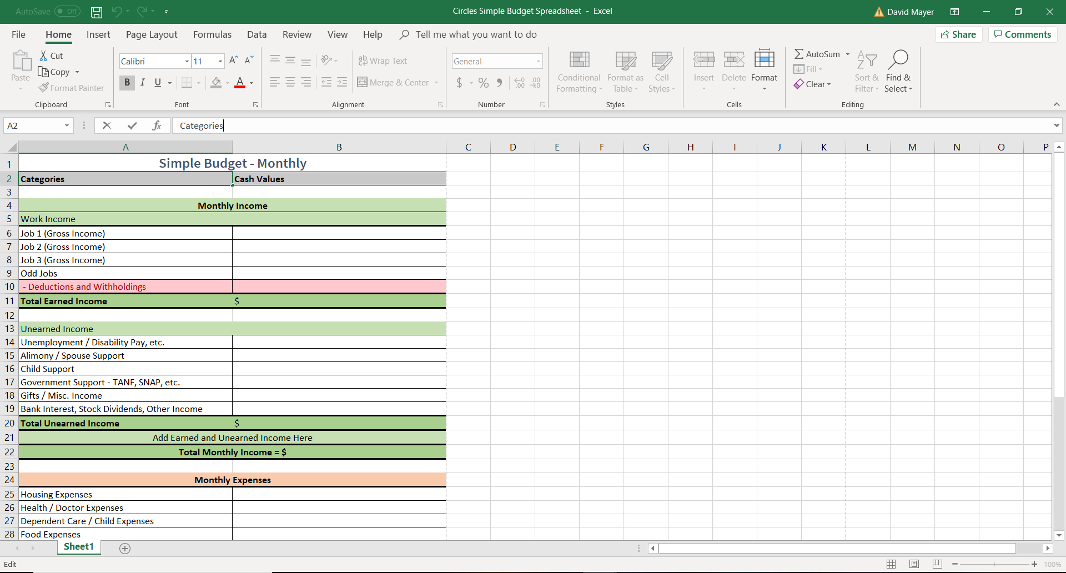

2

1

I have opened the Simple Budget Spreadsheet that you can find on our website. I’ll go over some ways to modify this workbook. Then I’ll ask you to try modifying the Simple Ledger.

**#1:** This is the name of the workbook now that I have saved the file as “Circles Simple Budget Spreadsheet”. It isn’t important to know that the name is at the top of the screen, but it is important to know what you name your workbooks. Be careful of replacing old workbooks with new workbooks of the same name. Note that it still says “Sheet1” in the bottom left corner. I only need one sheet, and I don’t need to change the name.

**#2:** The text bar is indicated by the top red circle. If you type anything new into Microsoft Excel, it appears in this box. If you want to change the text in any previous cells (cells are the little rectangles all over the workbook), just click on the cell and the contents will appear in the top text box. In the picture, I just clicked on the cell A2 and “Categories” appeared in the text box.

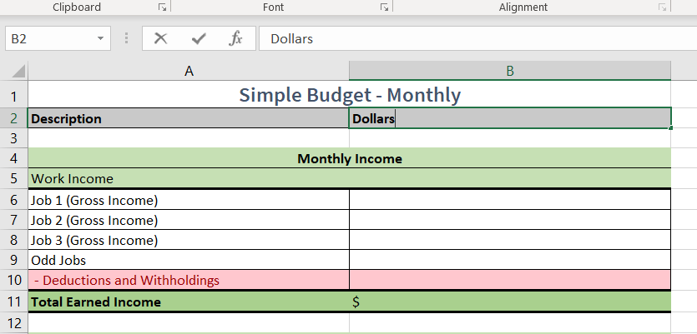

If you want to change the cells, you click the cell before you can modify it. First, I clicked on “Categories” and pressed backspace to delete the word. Next, I typed “Description”. I also clicked “Cash Values”, pressed backspace, and typed in “Dollars”. You will need to know that clicking with the left side of the mouse (left click) gives you different results than clicking with the right side of the mouse (right click). Left click only allows you to modify the cell you click on, and that cell will be highlighted with a green box.



For right click, the cell will still be highlighted with a green box, but you will be able to make more changes by clicking in the dropdown menus.

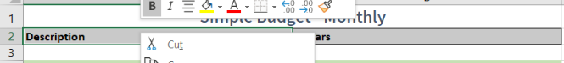

I’ll give a better example below. Here, I will use right click to modify my budget spreadsheet. 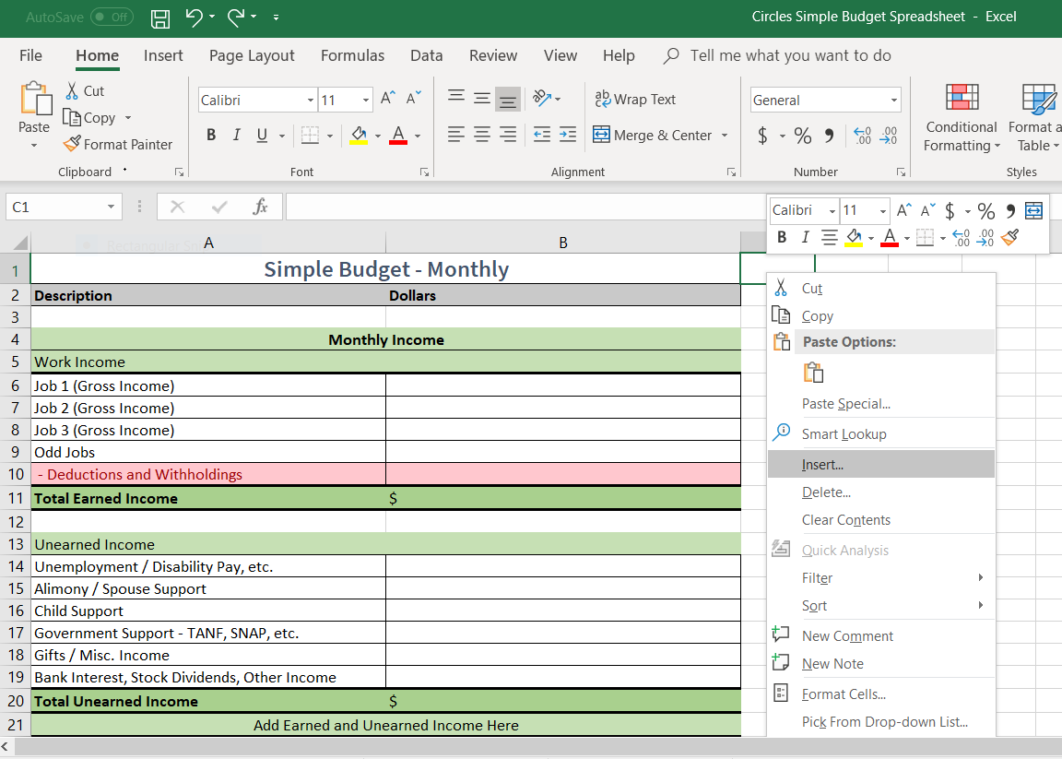

1

2

First, I right clicked on cell C1 (**#1**). Now I am about to left click on “Insert..” from the drag down menu (**#2**).

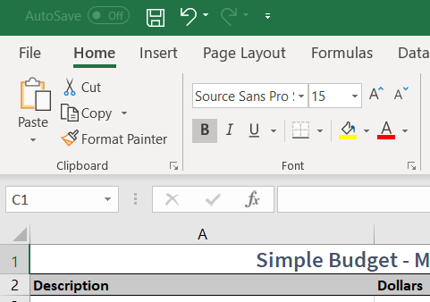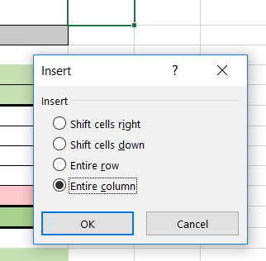

2

1

After clicking Insert… I see this popup. I will select “Entire column” (**#1**), because I want to add some notes to my table. I will show you how that looks on the next page.

**Warning:** Be careful what you click in excel. It is easy to click the wrong thing, or to preform an action that you did not want to perform. This arrow at the top of the screen next to the save icon (**#2**) is the undo button. Use undo to fix recent mistakes.

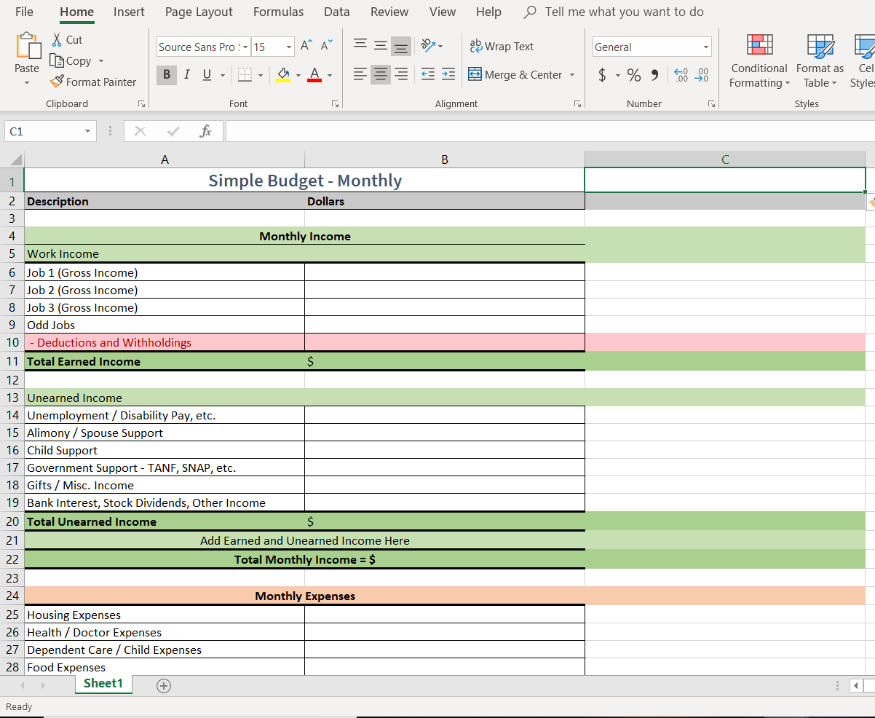

Above, I have added the new column. I’ll go over a few changes that can be made, but don’t worry about following instructions this time. Unlike the word tutorial, I don’t expect you to complete an activity. Instead, we will have a separate Microsoft Excel tutorial in which you can practice your excel skills.

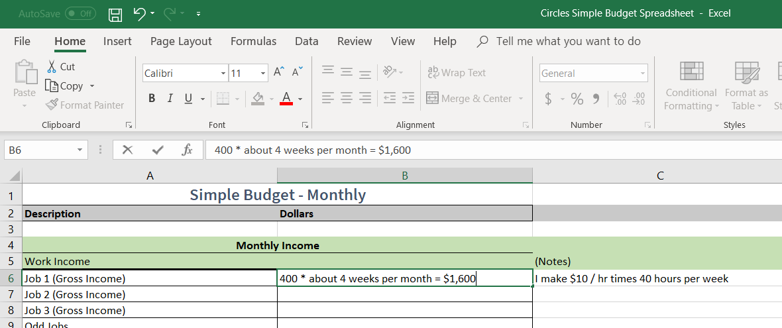

In this picture above, I started adding in notes to my spreadsheet. Say I make ten dollars per hour at my job. I only have one job, and I work forty hours every week. In this case, I estimated that to be about $1,600 per month. I might decide that my job should give me about $1,600 per month and write that as my budgeted total monthly income.

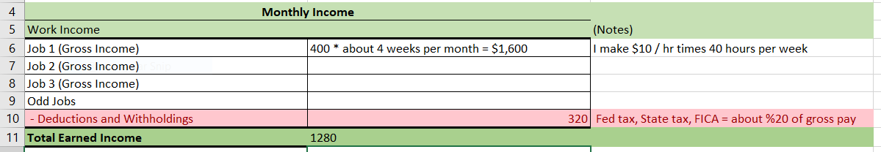

Later, I realized that I need to pay Federal, State and Local taxes and add to FICA (Social Security, Medicare, etc.). I figure that this will account for about 20% of my paycheck, so I don’t actually make $1,600. I really make $1,280 after deductions. The budget spreadsheet is more useful if you can make changes to your template budget, so it is good to learn how to make these changes in Excel.

For the next tutorial, I will explain how to use simple formulas, add/delete cells, and save your files.